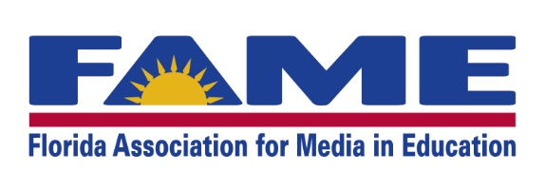
Haines City, Florida—A record number of Florida students, grades K-12, participated in the reading programs hosted by the Florida Association for Media in Education (FAME). 71,346 students participated in this year's FAME reading programs, which include Sunshine State Young Readers Award, Jr. for grades K-2, Sunshine State Young Readers Award for grades 3-5 and grades 6-8, and the Florida Teens Read Award for grades 9-12. Students are encouraged to read at least three books to able to vote for their favorite book, which means if each student read three books, at least 214,048 books were read by Florida students.

The mission of all three programs, SSYRA, Jr., SSYRA, and FTR is to encourage students to read for pleasure and expose them to a wide range of books. Although librarians select the books for each list, the students vote for their favorite in each age group. While SSYRA for grades 3-8 and FTR have been around for many years, SSYRA, Jr. is a brand new program that started in the 2015-2016 school year as a way to foster the love of reading early in Florida students.

The winners for the 2015-2016 school year as chosen by Florida students are: Dog vs. Cat by Chris Gall for SSYRA, Jr.; Pie by Sarah Weeks for SSYRA grades 3-5; Stung by Bethany Wiggins for SSYRA grades 6-8; and The Program by Suzanne Young for FTR.

"These reading programs are important because they are student-choice programs. Not only do students have a choice in which titles from the lists that they read for pleasure, but they are choosing which book wins the award for our state. Other book awards are chosen by adults, but these awards are chosen by the intended audience for which the authors write: the kids and teens,” FAME President Lucretia Miller explains. “It is vital that we encourage our students to maintain the habit of recreational reading, because statistics show that as children get older, the amount of reading for their own enjoyment drastically declines. FAME's reading programs are geared toward thwarting those statistics. By offering students at every age level from Kindergarten through 12th grade a fun program with titles that interest them, students will hopefully not only build a love of reading, but maintain the habit as well."

Visit the FAME website at http://www.floridamediaed.org/programs.html for more information on these programs.

###
