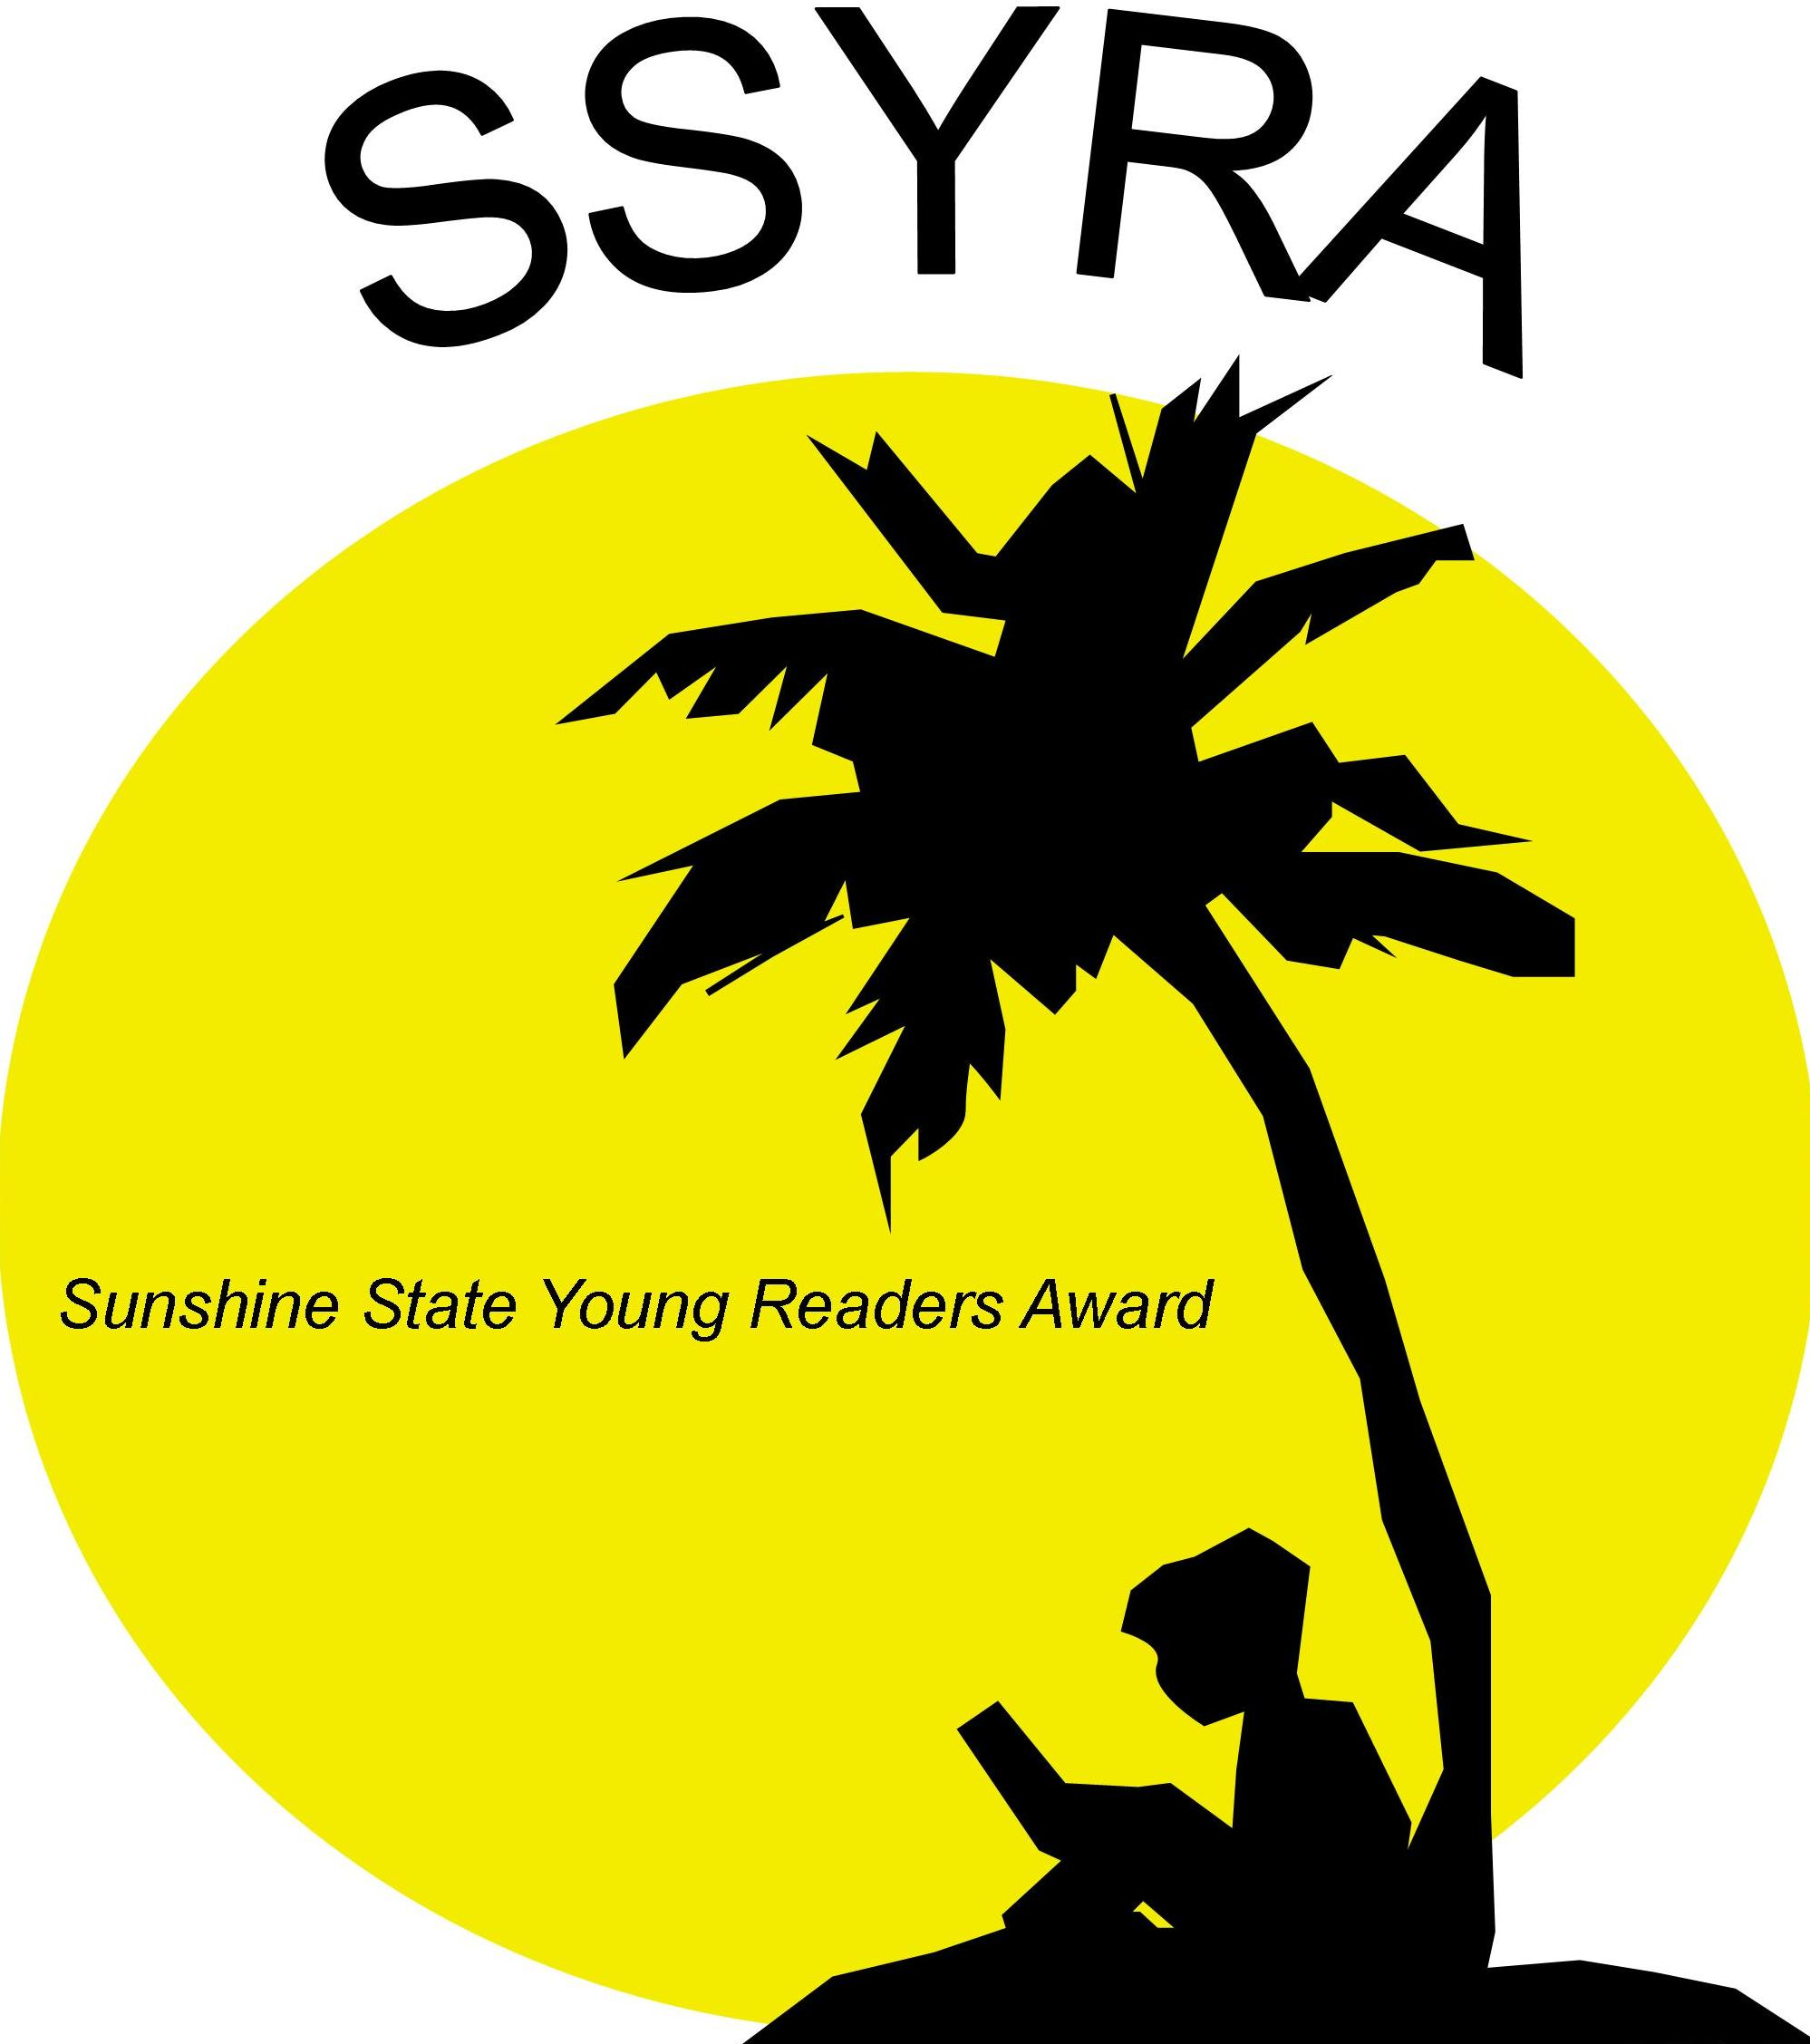
2018 SSYRA - First Line of the Books
Grades 6-8

A Crack in the Sea: “When Kinchen came back from milking the goats, Old Ren sat up in bed and told her that Pip was gone.”

Click’d: “Allie tightened her grip on her phone as she stepped from behind the curtain and walked to the center of the stage.”

Curse of the Boggin: “It was under the bed.””

First Rule of Punk: “Dad says punk rock only comes in one volume: loud. So when I slipped my headphones over my ears, I turned the music up until bass strings thumped, cymbals hissed, and guitar strings squealed like they were having a conversation with each other.”

Forest of Wonders: “Raffa hesitated at the head of the steep stairs, a lantern in his hand. There was nothing wrong with going into the cellar, he told himself firmly.”

Frogkisser!: “The scream was very loud and went on for a very long time.”

Ghost: “CHECK THIS OUT.”

How Lunchbox Jones Saved Me from Robots, Traitors, and Missy the Cruel: “Rumor had it that inside the Forest Shad Middle School’s mascot costume was a seventy-two-year-old woman.”

Restart: “I remember falling”

Short: “I’m officially resigning from love.”

The Epic Fail of Arturo Zamora: “Some secrets are small--the size of a battery, or a button, or a scrap of paper.”

The Eureka Key: “Sam’s eyes were on the clock: 9:54.”

The Firefly Code: “Everyone goes to sleep at the same time on Firefly Lane.”

The Girl Who Could Not Dream: “Sophie had only ever stolen one dream.”

The Van Gogh Deception: “For almost three hundred years, the simple stone structures on the outskirts of the small French village of Locronan had served as home to a family of farmers.”

