Edge of Extinction: The Ark Plan
by Laura Martin

Annotation
Five years ago, Sky Mundy’s father vanished from North Compound without a trace. Now she has just stumbled on a clue that not only suggests his disappearance is just the tip of an even larger mystery, but also points directly to the surface. To find her dad—and possibly even save the world—Sky and her best friend, Shawn, must break out of their underground home and venture topside to a land reclaimed by nature and ruled by dinosaurs.

Book Talk
150 years ago the first dinosaurs were cloned and then nearly wiped out the human race. The only way to survive was to move underground. Imagine yourself in Jurassic Park.

Book Trailers
- https://m.youtube.com/watch?v=8Plfd3vtRCA
- https://m.youtube.com/watch?t=7s&v=LQZN1YgfiTA

Author on the Internet
- Website: www.lauramartinbooks.com
- Twitter: @LauraMartinBook

Items to use in a library display
- Dinosaur bone
- Compass
- Arrow
- Copy of topside map (p. 222)

Book Club Discussion Questions/Topics
- What dinosaur would you fear the most and why?
- Would you prefer to live in the Compound or the Oaks?
- Do you think dinosaurs could be cloned? Should they be cloned?
- Do you think it was fair how Sky was treated in the compound after her father disappeared?
- What do you think they will find at the lake?
- What makes Shawn a good friend?
- Do you think the Noah is a good person?

First Line of the Book:
“I needed two minutes.”

Non-Fiction Companion Title(s)
- Dinosaurs (Magic Tree House Research Guide) by Will Osborne, Mary Pope Osborne
- Digging Up Dinosaurs by Aliki
- Fly Guy Presents Dinosaurs by Tedd Arnold
- Scary Spotted Feathered Frilled by Catherine Thimmesh

What to Read Next
- Code Name Flood by Laura Martin
- Fossil by Bill Thomson
- Ends of the Earth by Bruce Hale
- The Adventurer’s Guide to Successful Escapes by Wade Albert White
- The Trials of Morrison Crow by Jessica Townsend

Other Books by this Author
- Code Name Flood- Edge of Extinction #2
- Float

Additional Resources
- Build a Dino STEAM challenge (Makerspace)- Given straws and marshmallows, challenge students to make a dinosaur. If possible, have plastic dinosaurs or dinosaur books as models for them to recreate.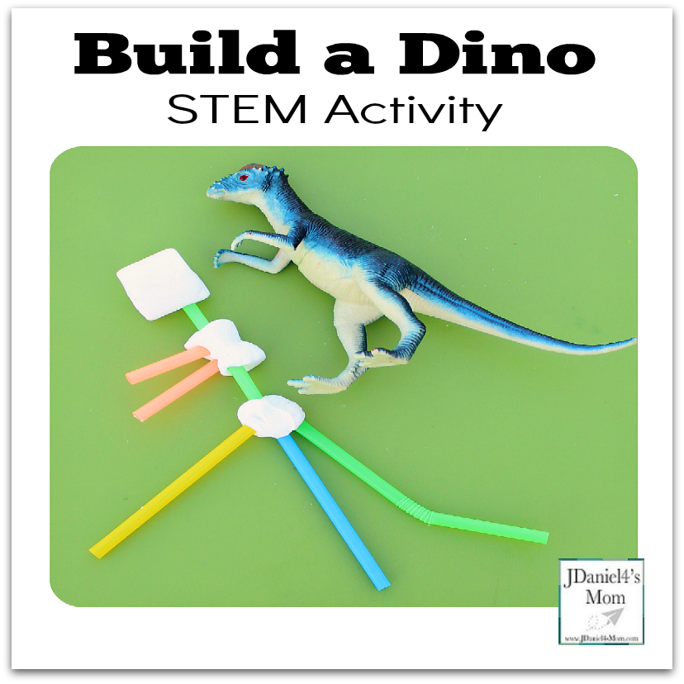
- Games to Teach Using a Compass - https://www.eurekacamping.com/blog/article/3-games-teach-kids-use-compass
- Q and A with Laura Martin - https://www.brockeastman.com/news--reviews/qa-with-laura-martin
- Paleontology website from American Museum of Natural History https://www.brockeastman.com/news--reviews/qa-with-laura-martin
- Mining for Fossil Fuels - cookie lab https://sarasglobalcooking.blogspot.com/2012/01/blog-post.html
- Scale City- comparing person to T-Rex. Available in English and spanish. https://ca.pbslearningmedia.org/resource/mket.math.rp.sizeorama/one-dimensional-scaling-to-find-unknown-heights/?#.WqQyppFOmhA
- Bulletin Board - Dinosaurs didn't read. Now they are extinct.
- Science - eggshell geodes. https://www.stevespanglerscience.com/lab/experiments/incredible-egg-geode/

Name that Book:
“I always thought that I wouldn't put you in danger for the world, but it turns out that for the world, I will.” (p. 64)

“We pledge obedience to the cause of the survival of the human race.” (p. 16)

“You live up there? I breathed. “In the sky?” (p. 120)

“I was seven the night my dad disappeared.” (p. 296)

“I was the daughter of parents who died in the fight for freedom and independence.” (p. 344)

