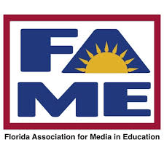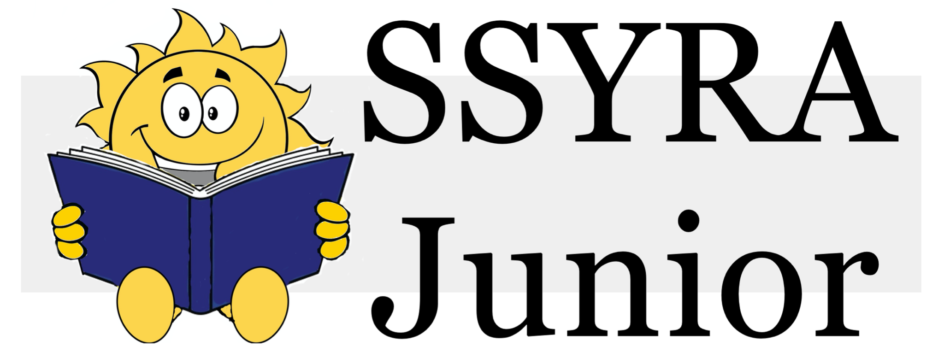
The Sunshine State Young Readers Award Junior Books
2021-2022
Picture Books:
The One and Only Dylan St. Claire by Kamen Edwards Illustrated by Jeffery Ebbeler
The Yawns are Coming! by Christopher Eliopoulous
The Barnabus Project by the Fan Brothers
How to be a Pirate by Isaac Fitzgerald
Federico and the Wolf by Rebecca Gomez Illustrated by Elisa Chavarri
Kamala and Maya’s Big Idea by Meena Harris Illustrated by Ana Gonzalez
You Matter by Christian Robinson
Roy Digs Dirt by David Shannon
Fussy Flamingo by Shelly Vaughan James Illustrated by Matthew Riviera
Unicorns are the Worst by Alex Willan
Independent Readers:
Shark Report by Derek Anderson
Puppy Problems by Paige Braddock
See the Cat by David La Rochelle Illustrated by Mike Wohnoutka
Geeger the Robot Goes to School by Jarrett Lerner
Ready for School! by Bob McMahon

